API Gateway

The API Gateway serves as the single entry point for all client requests, managing and routing them to the appropriate microservices.

Eureka Server

Eureka Server is an application that holds the information about all client-service applications. Every Micro service will register into the Eureka server and Eureka server knows all the client applications running on each port and IP address. Eureka Server is also known as Discovery Server

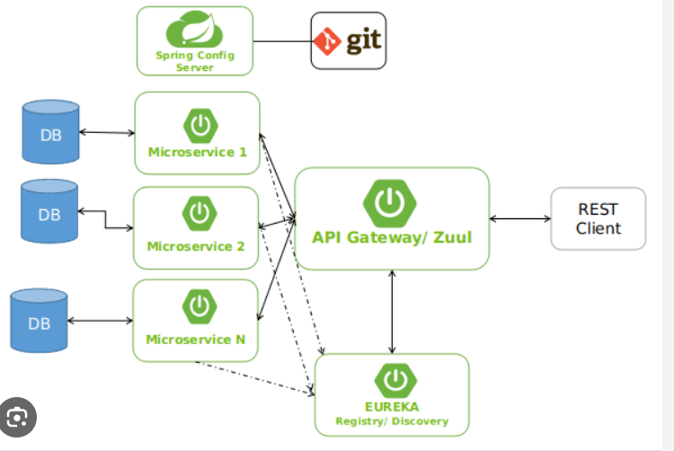

1.user-service project run first

2.contact-service project run

2.1 Employee-microservice project

3.e-server run

http://localhost:8761/

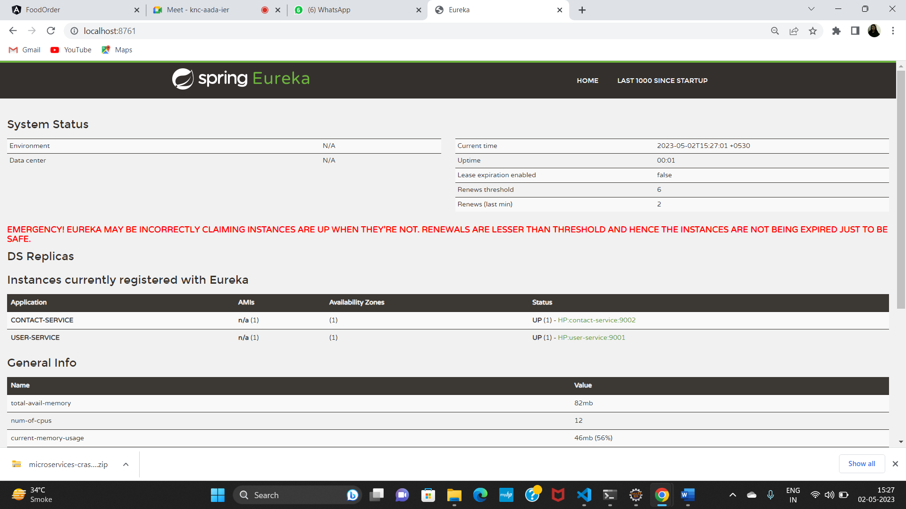

4.api gateway project

<http://localhost:8999/api/v1/employees>

<http://localhost:8999/contact/user/1311>

<http://localhost:8999/user/1311>

Add one more project emp management system

Pom.xml

Add cloud and eureka-client

Emp project inside make application.yml file(note:port is there in application.properties file then remove it or comment it)

Now opn api gateway project

Open application.yml file

- id: employee-service

uri: lb://employee-service

predicates:

- Path=/api/v1/\*\*

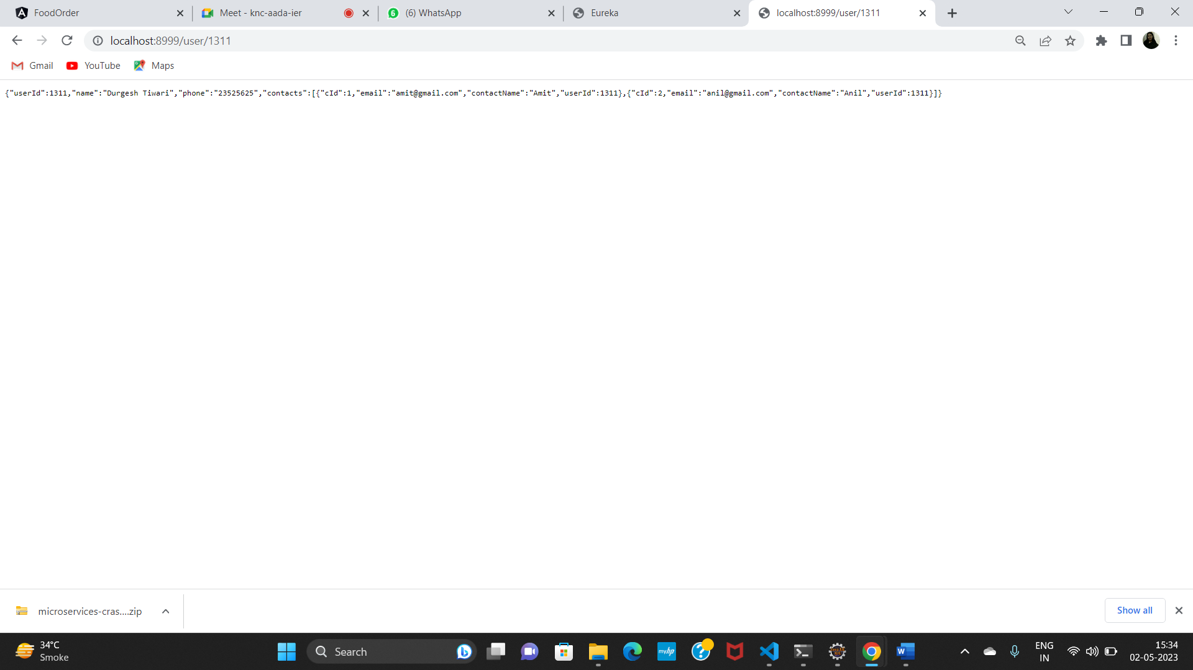

Then u can insert ,delete,update mployee using api gate way port

(8999)

